**EDU LEARN – USER DOCUMENTATION**

**(TEAM-03)**

**Wiki-page:** <https://github.com/s566466div/GDP-Project-EduLearn-03/wiki/User-Documentation>

**Use Cases:**

**Use case 1: User Registration**

**Goal:** As a new user (Student or Instructor), I want to securely register for an account on the platform.

**Input:**

* User navigates to the registration page.
* User provides personal information such as name, email, and password.

**System Interactions:**

* System validates the provided information.
* If validation is successful, the system creates a new user account.
* If validation fails or there are errors, the system displays appropriate error messages.

**Expected Output:** Confirmation of successful registration or error messages for unsuccessful registration attempts.

**User Registration with valid fields**

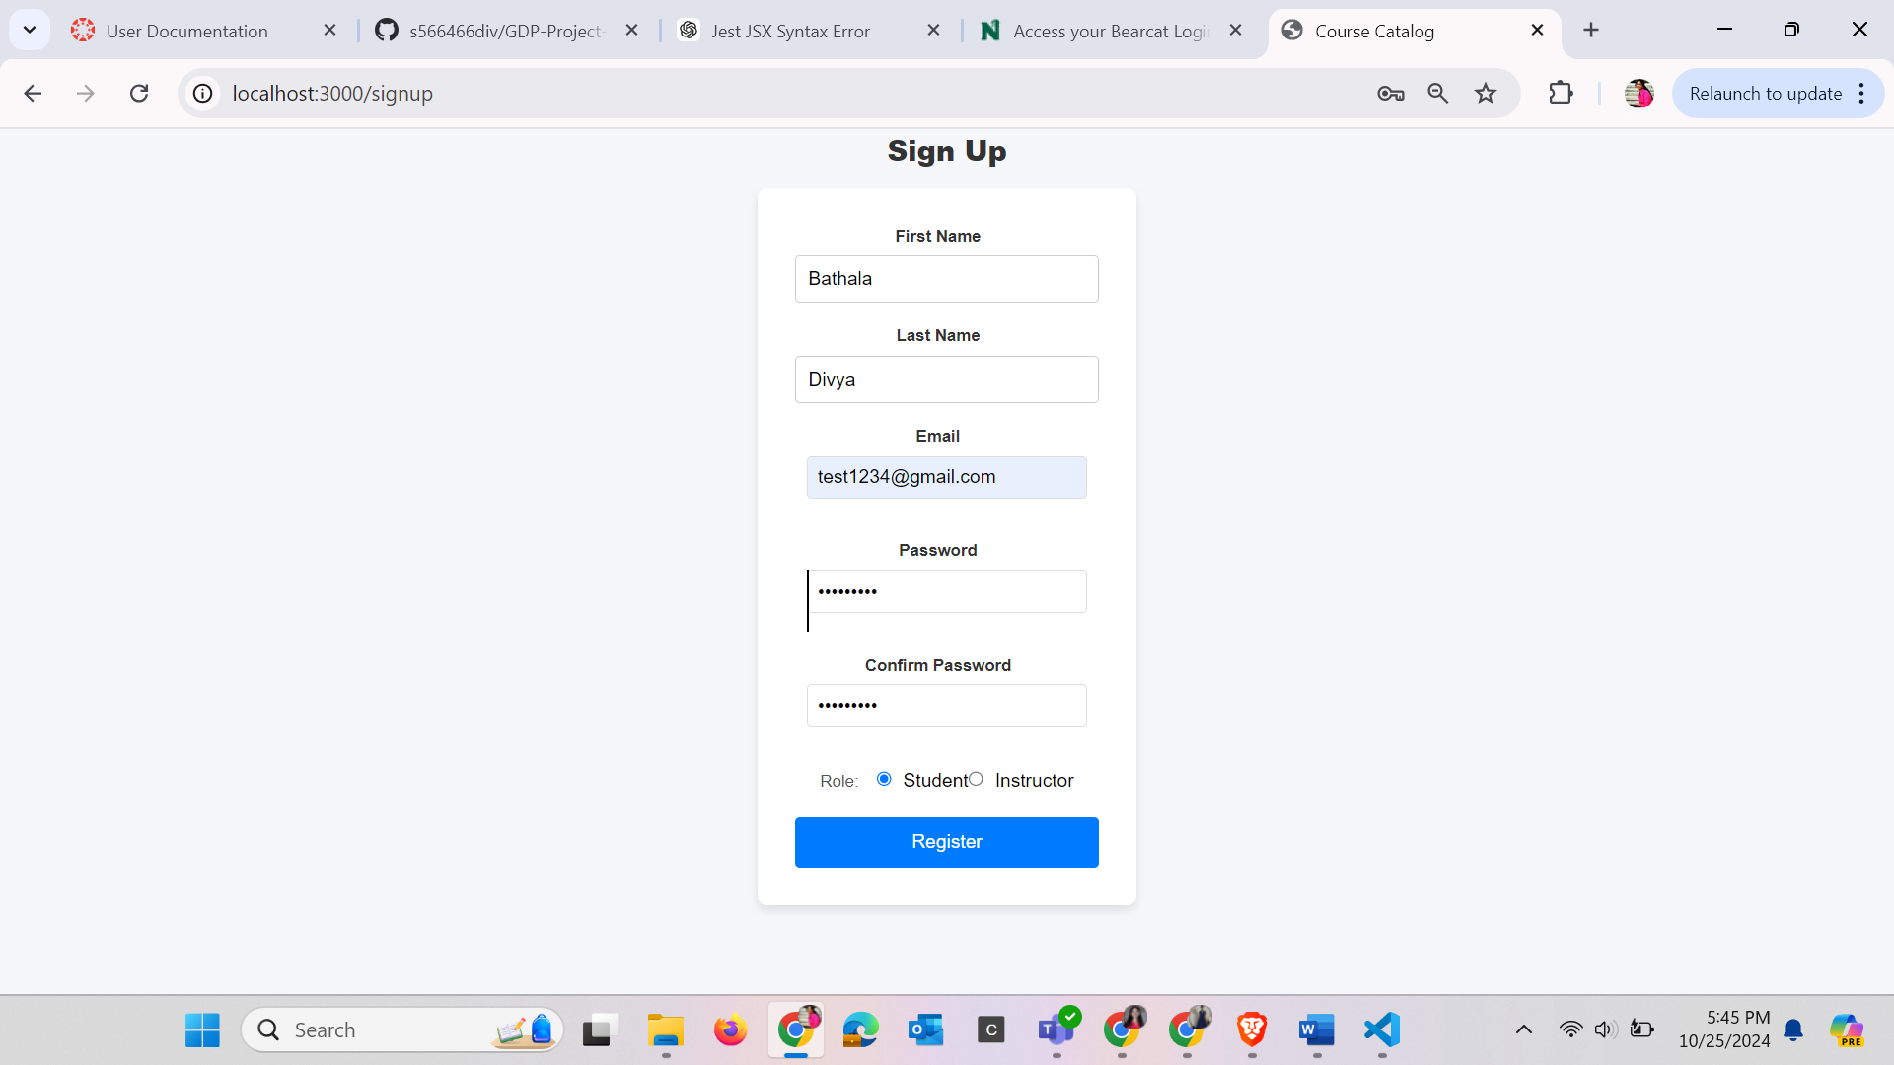

**After User Registration Saved Credentials**

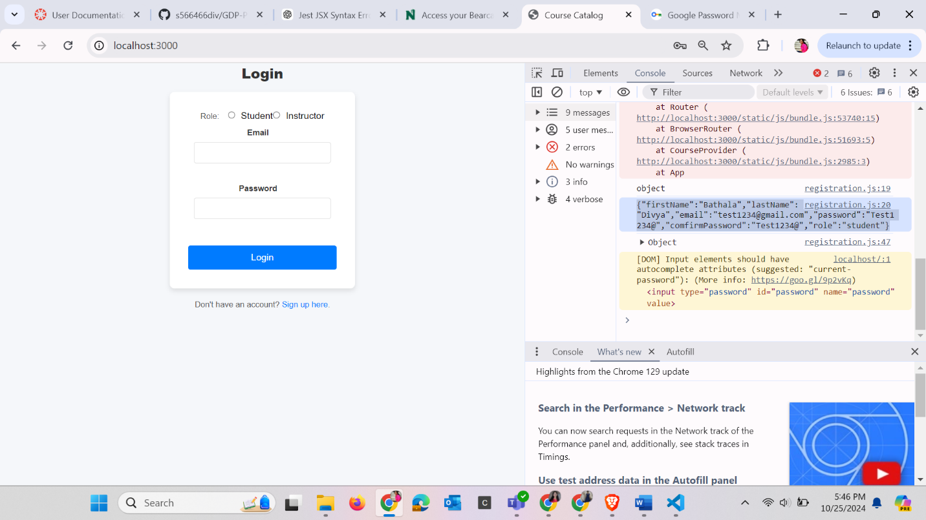

**Invalid Field Values**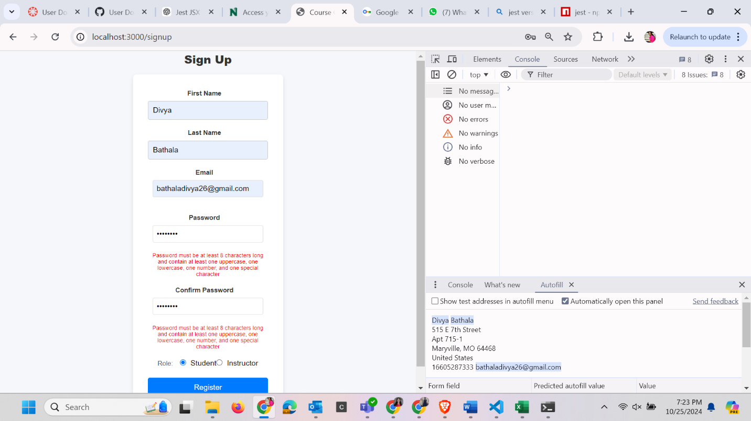

**Use Case 2: User Authentication**

**Goal:** As a registered user (Student or Instructor), I want to securely authenticate myself to access the platform.

**Input:**

* User navigates to the login page.
* User enters their username (email) and password.

**System Interactions:**

* System validates the credentials.
* If credentials are valid, system grants access to the user's account.
* If credentials are invalid, system displays an error message.

**Expected Output:** Successful login, granting access to user's profile or error message for invalid credentials.

**Login Page**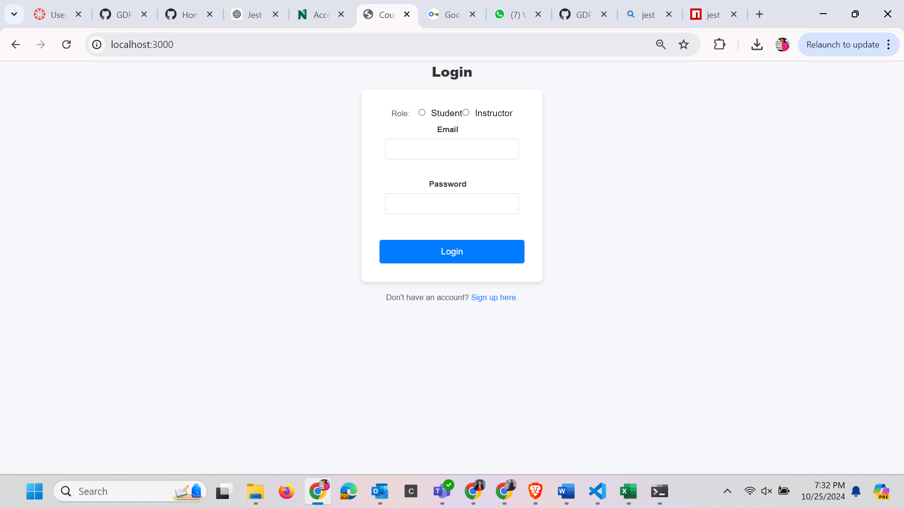

**User with valid credentials**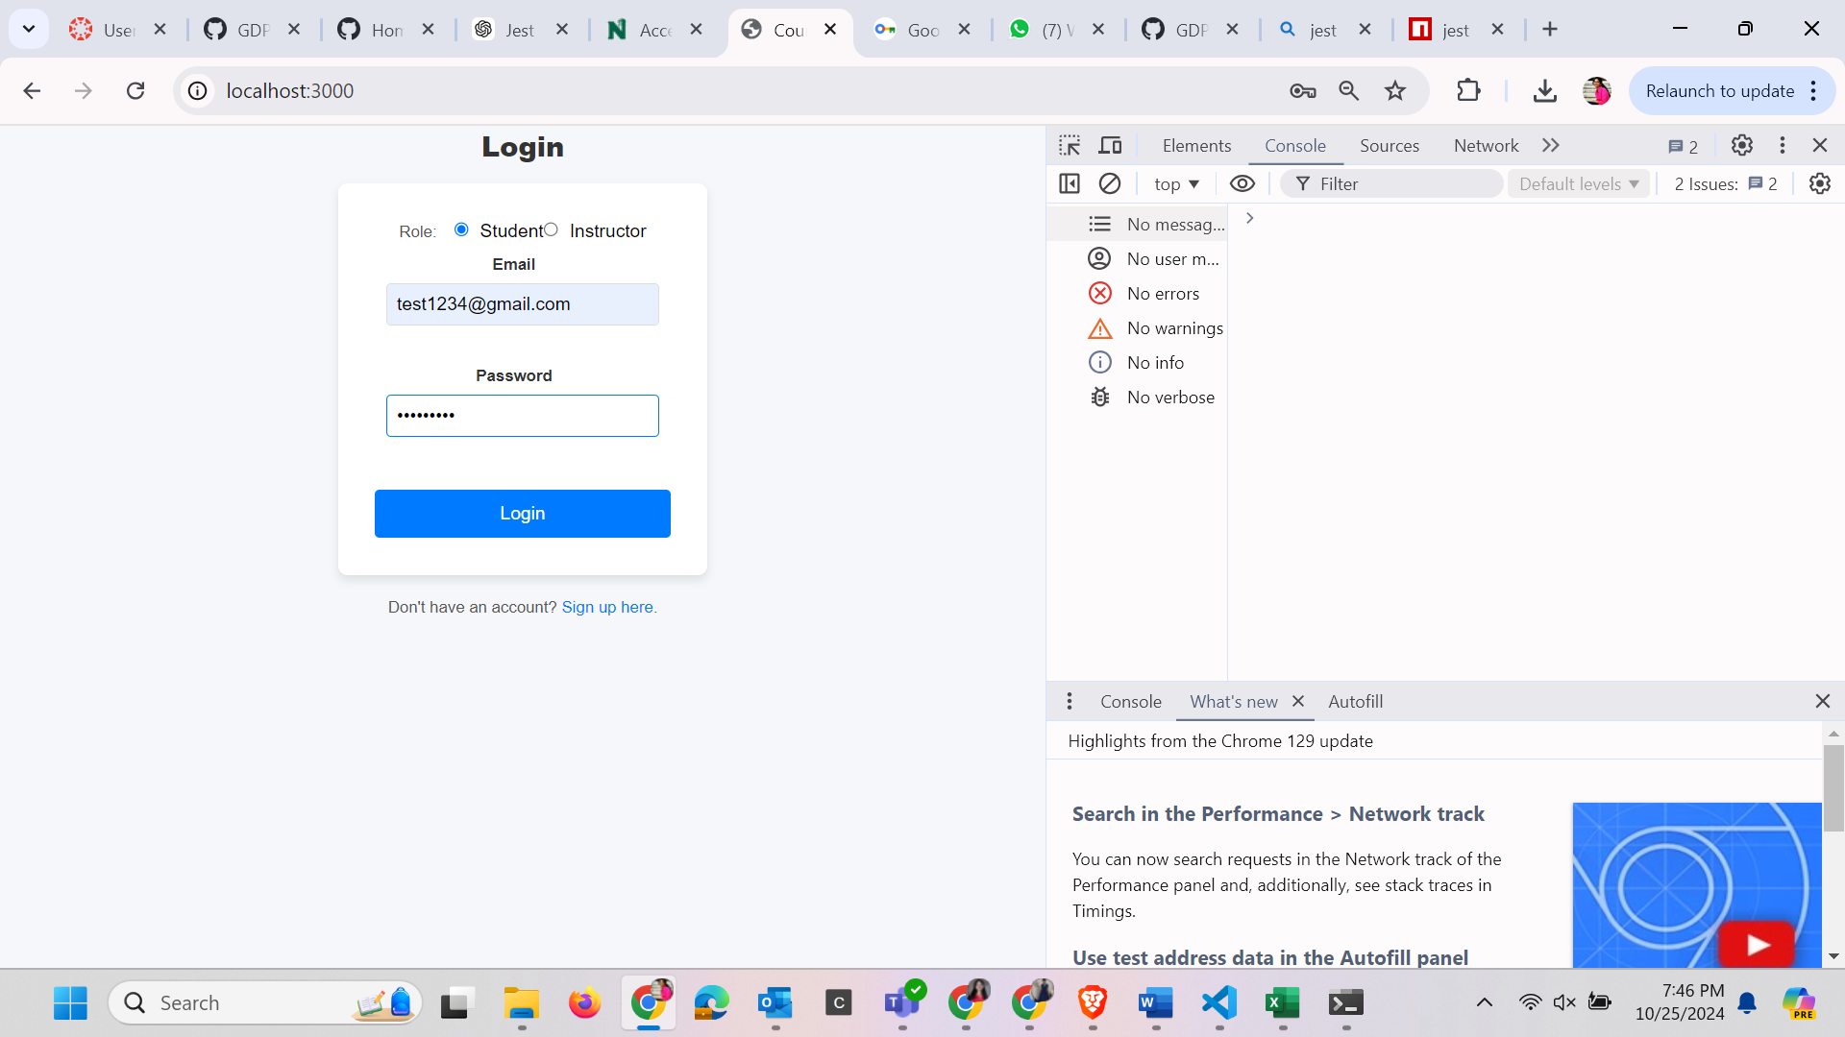

**With Valid credentials granting access to user's profile Dashboard**

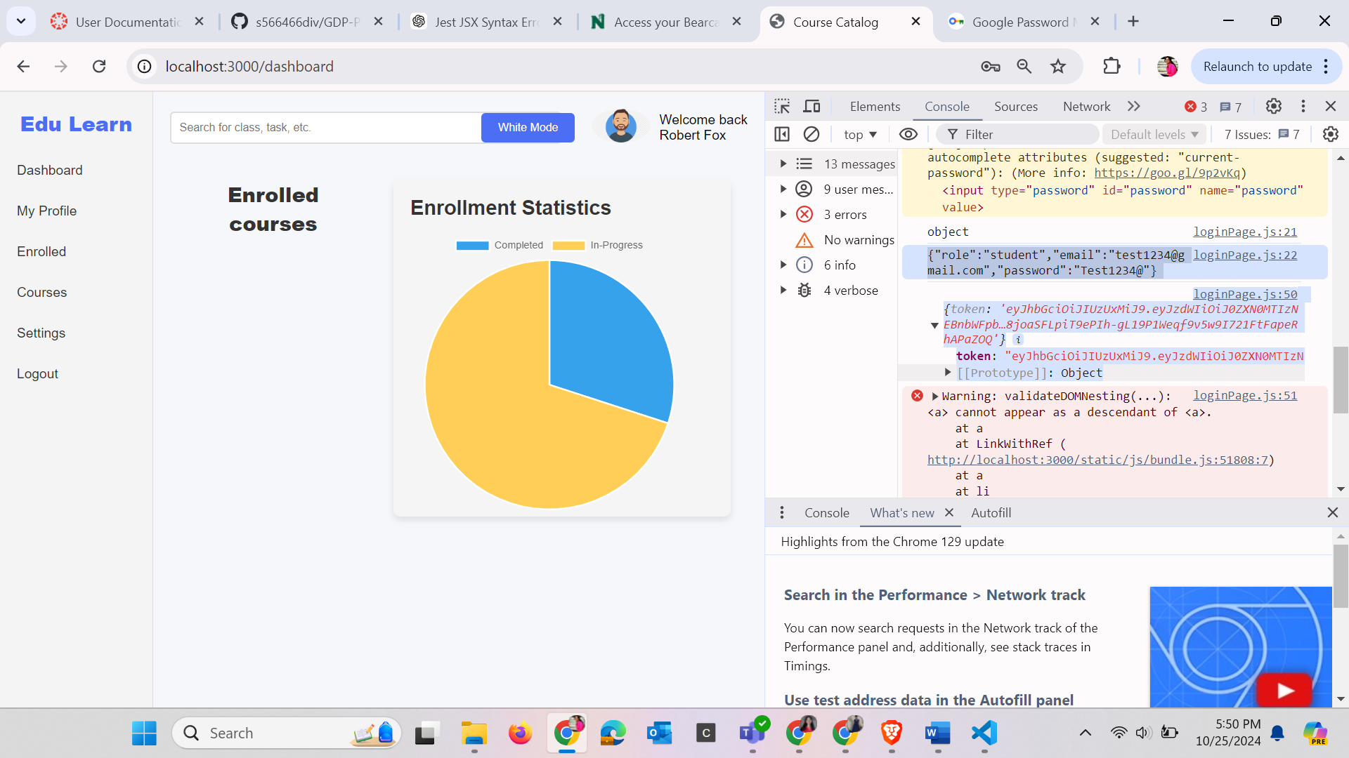

**With Invalid credentials and error** 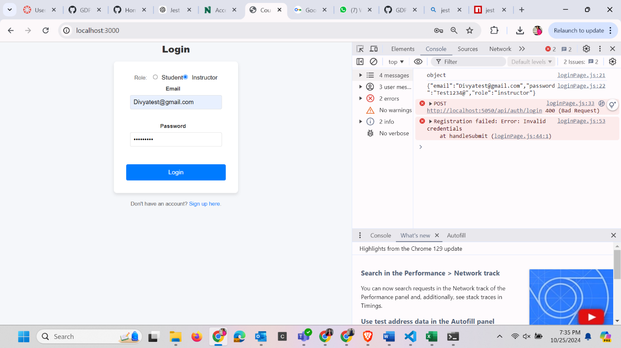

**Use Case 3: Course Catalog**

**Goal:** As a student, I want to browse available courses and view detailed information about courses.

**Input:**

* Student navigates to the course catalog.
* Student utilizes search and filtering options to find courses matching their interests or requirements.
* Student clicks on a course to view detailed information.

**System Interactions:**

* System presents a list of available courses with relevant details such as title and description.
* Student can click on a course to view more detailed information.
* System provides options for sorting and filtering courses based on criteria like subject or discipline.

**Expected Output:** Student interacts with the course catalog, viewing detailed information about available courses.

**Without any Filters**

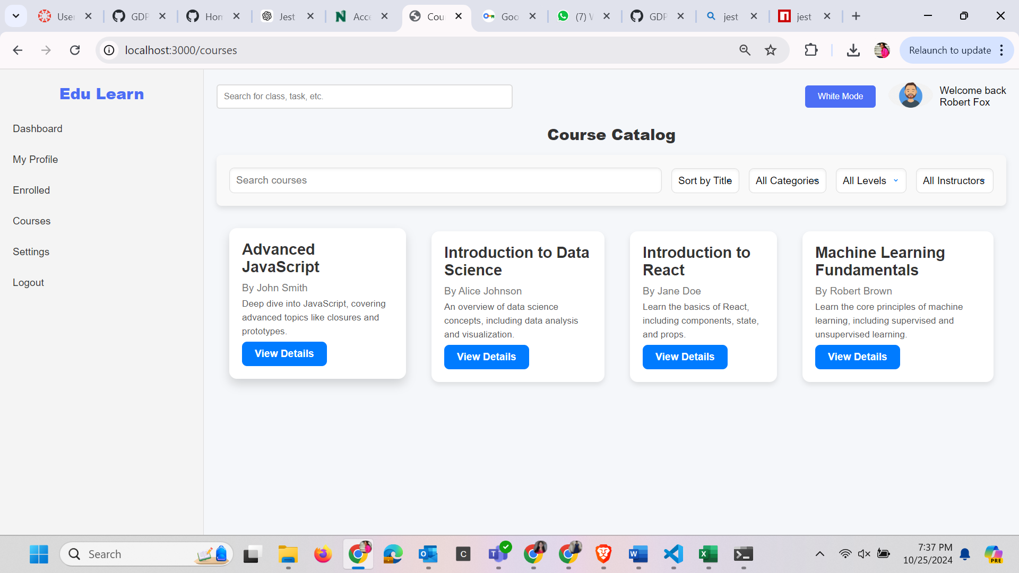

**With search option**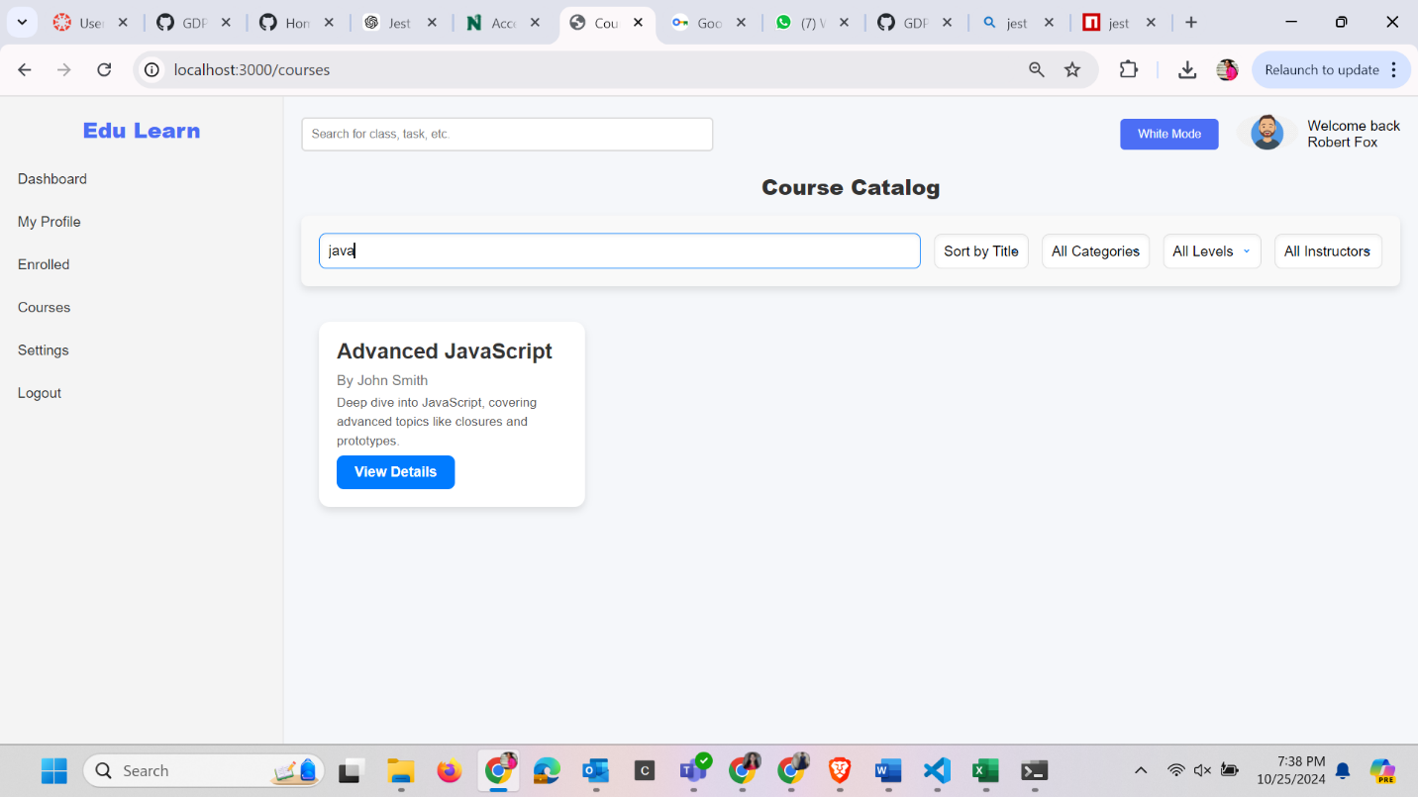

**With Filters Applied** 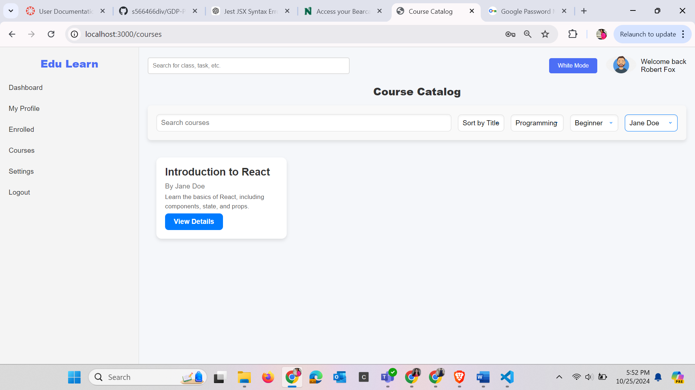

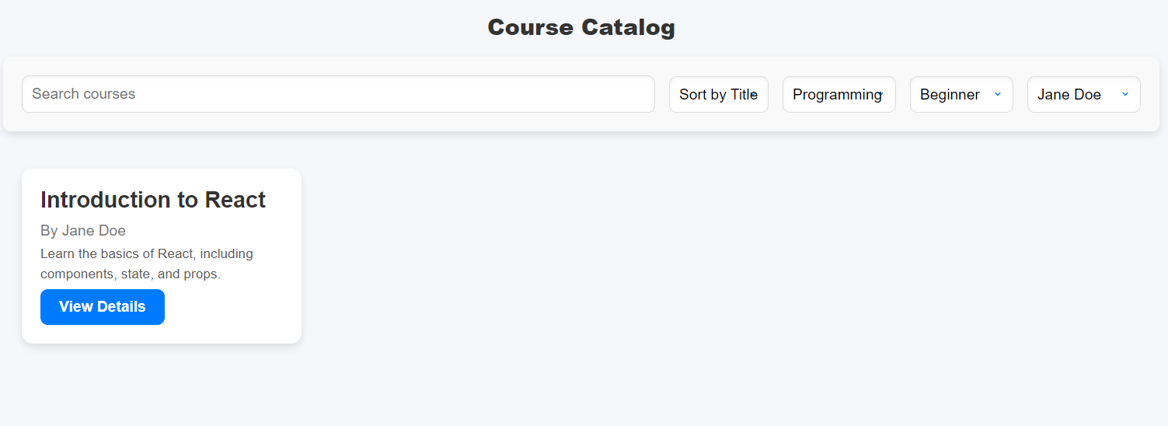

**Use Case 4:** **Browse and Enroll in Courses**

**Goal:** As a student, I want to browse available courses and enroll in courses that I am interested in.

**Input:**

* Student navigates to the course catalog.
* Student browses available courses or uses search and filtering options to find specific courses.
* Students go through course information across various subjects and disciplines.

**System Interactions:**

* If satisfied, Student enrolls in the course.
* Student receives confirmation of successful enrollment.

**Expected Output:** Successful enrollment of courses.

**Course Ready For Enrollment** 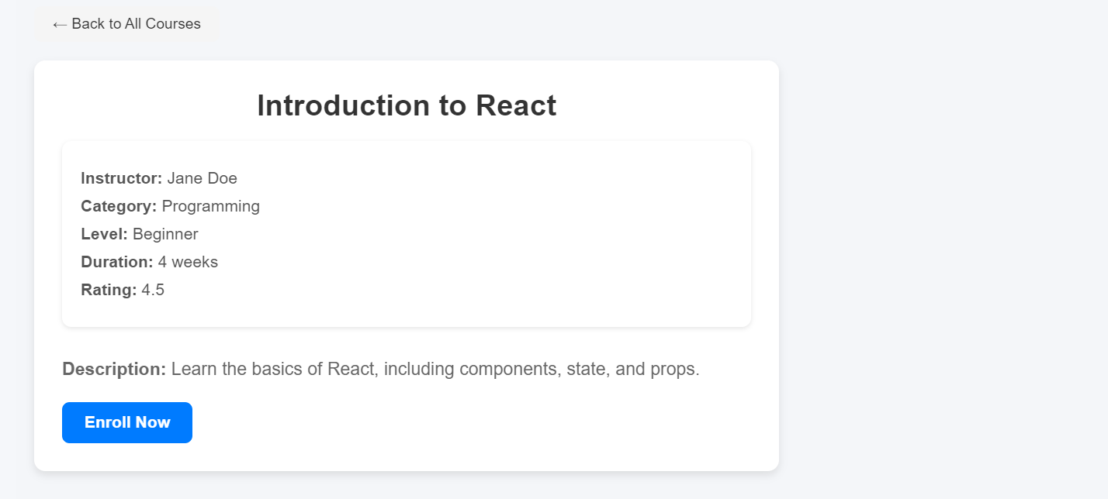

**When we click on Enroll Button**

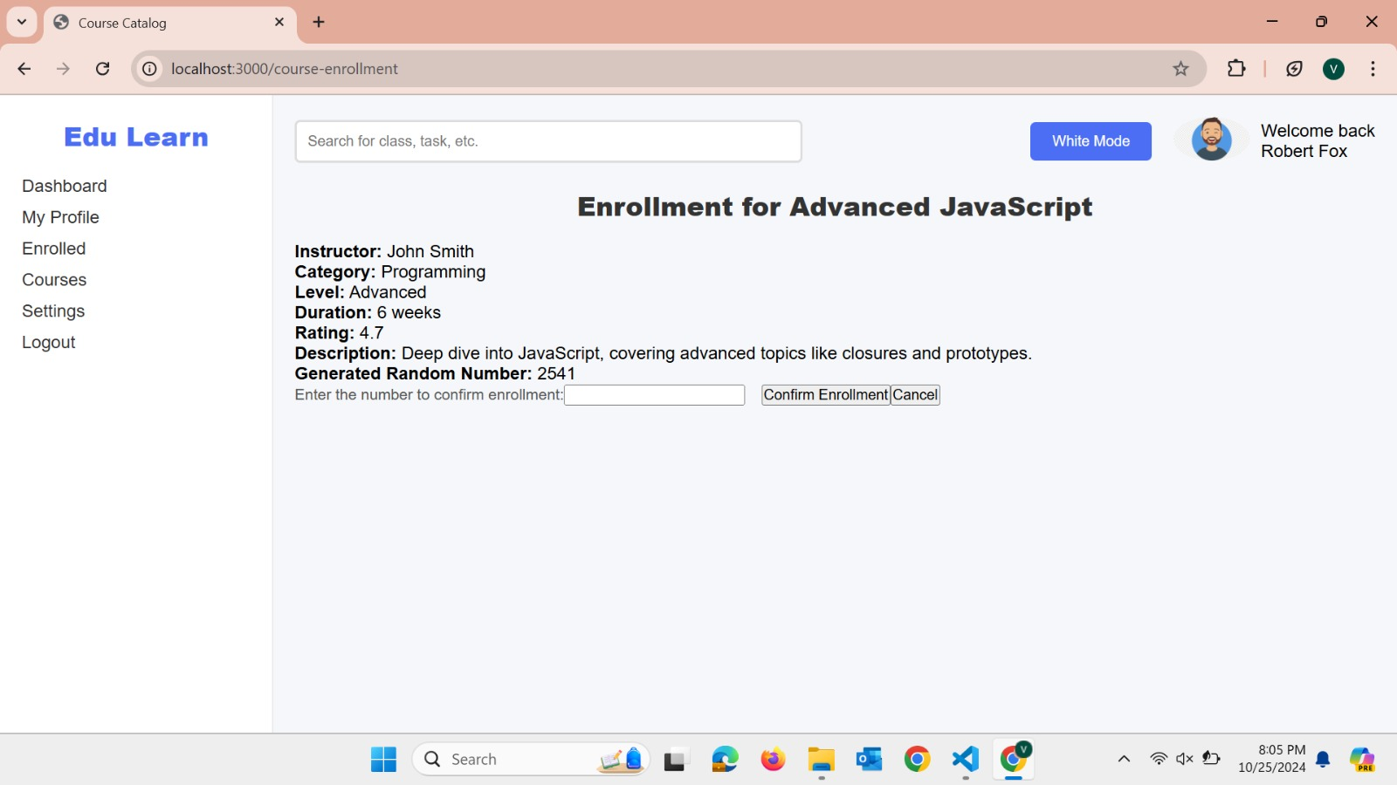

**Successfully enrollment of courses** 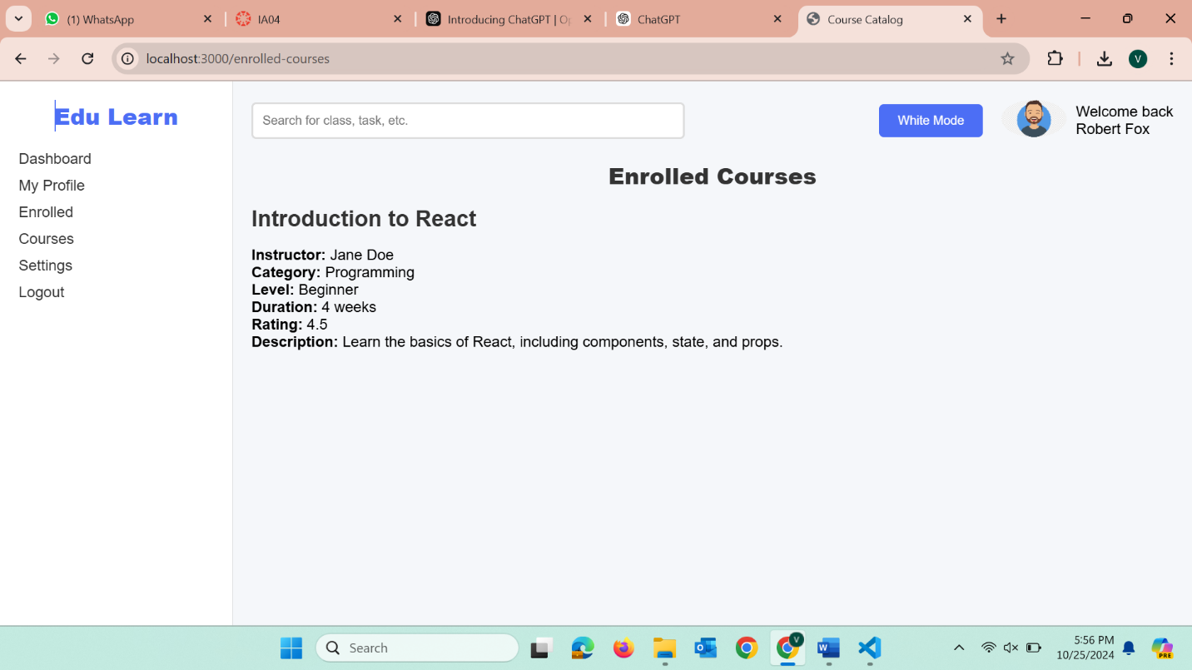

**Use Case 5: Course Dashboard**

**Goal:** As a student, I want to interact with a user-friendly course dashboard that logically organizes course content for easy navigation.

**Input:**

* Student accesses the course dashboard for the enrolled course.
* Student navigates through different sections of the dashboard.

**System Interactions:**

* System displays an organized course dashboard.
* Student clicks on various sections to access course materials and track progress.

**Expected Output:** Student interacts with a logically organized course dashboard, facilitating easy navigation and access to course content.

**Course Dashboard** 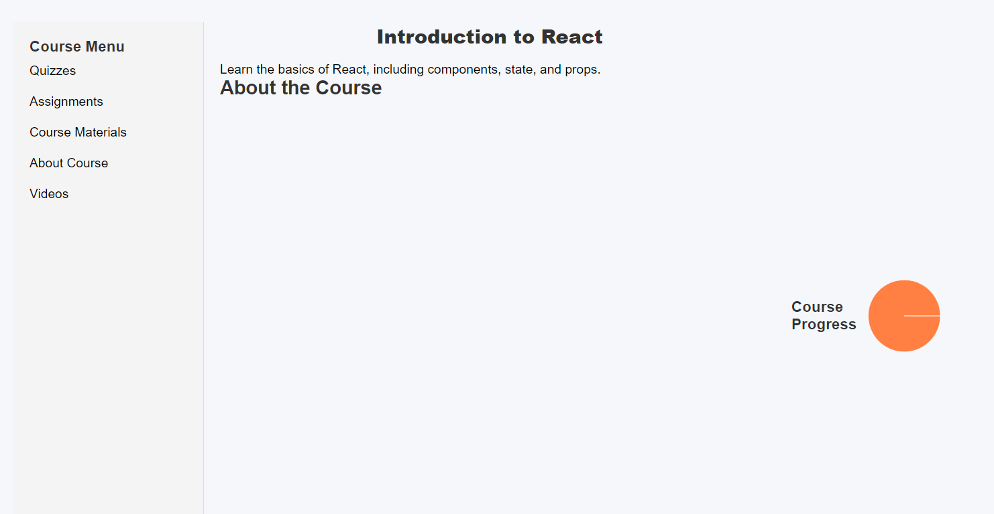

**Use Case 6: Access Course Content**

**Goal:** As an enrolled student, I want to access course materials such as video lectures, reading materials, assignments, and quizzes.

**Input:**

* Student selects the enrolled course they want to access.
* Student selects a specific item (video lecture, reading material, assignment, quiz) to view.

**System Interactions:**

* System presents the course dashboard with video lectures, reading materials, assignments, and quizzes.
* System retrieves and displays the selected content.
* Student interacts with the content as needed.

**Expected Output:** Student will be able to access all the course content.

**Use Case 7: Complete quizzes and assignments.**

**Goal:** As a student, I want to complete quizzes and assignments to assess my learning progress.

**Input:**

* Student navigates to the course dashboard.
* Student selects the quiz or assignment they want to complete.

**System Interactions:**

* Student completes the quiz or assignment.
* System evaluates the user's responses and provides feedback.
* System updates user progress based on completed quizzes and assignments.

**Expected Output:** Student will be able to complete Quizzes and Assignments.

**Use Case 8: Progress Tracker**

**Goal:** As a student, I want to track my overall learning progress, showing completed and pending tasks.

**Input:**

* Student can click on a specific course to view detailed progress information.

**System Interactions:**

* System displays a summary of completed tasks and pending tasks for each enrolled course.
* System provides detailed progress information such as completed or pending lectures, assignments, and quizzes.

**Expected Output:** Progress tracker showing completed and pending tasks.

**Overall Course and Enrollment Tracking**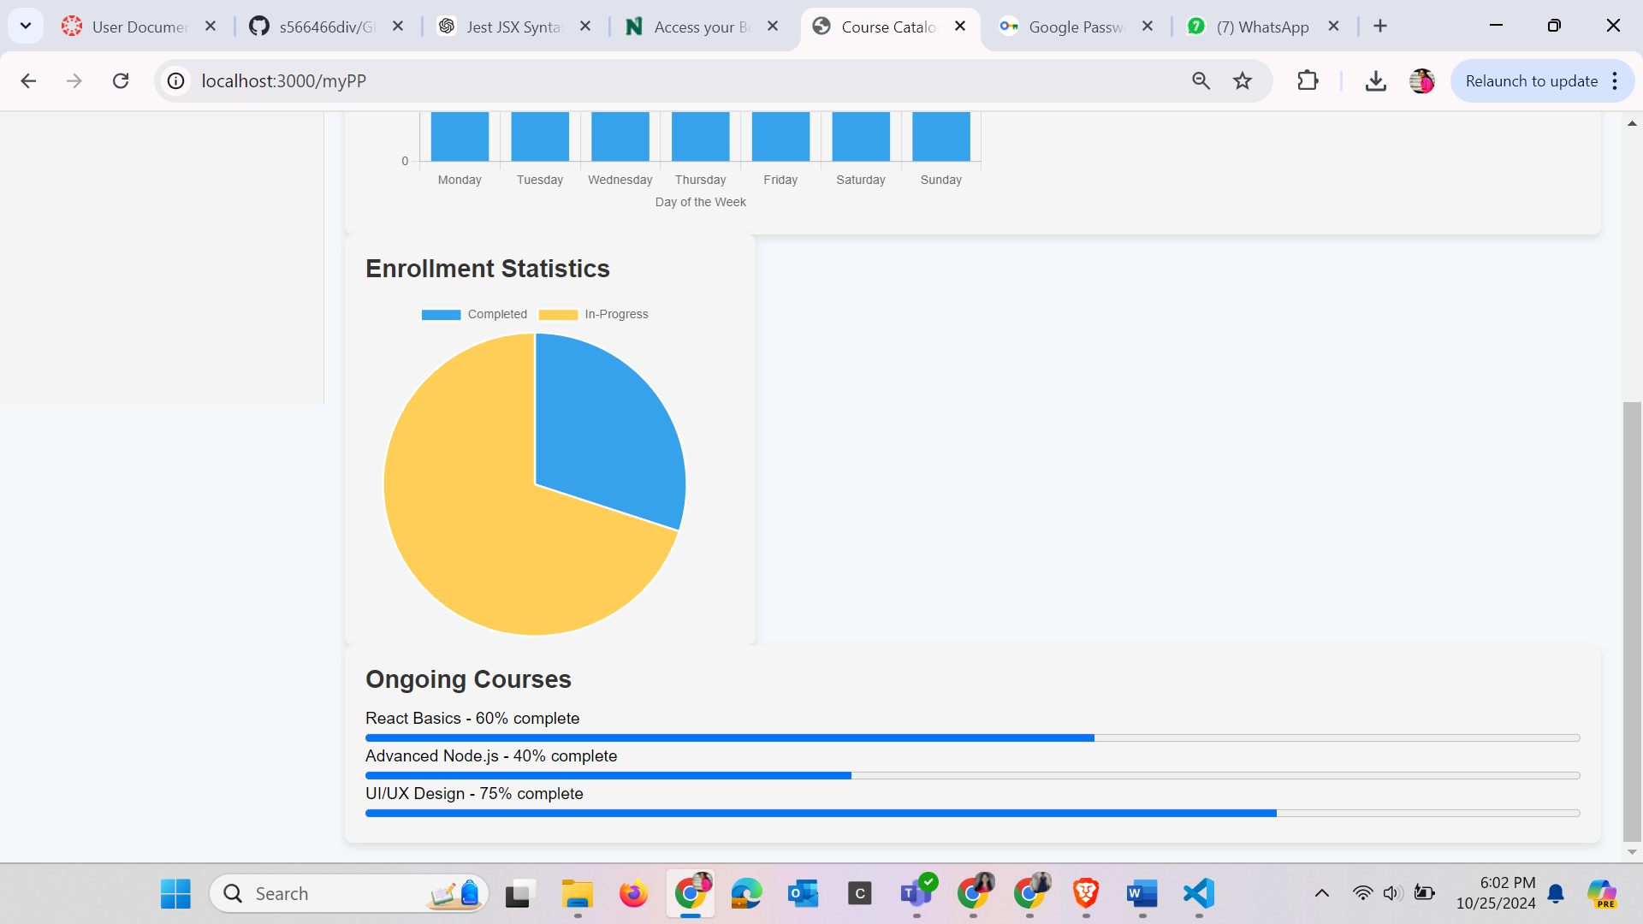

**‘**

**USE-CASE DIAGRAM:**

